CHAPTER FOUR

SYSTEM IMPLEMENTATION
This chapter describes the procedures and implementation of the proposed mobile-based Event Management System. It explains the development tools used, the implementation environment, and presents sample outputs of the system’s user interface. Illustrations are provided to help visualize the application and its main features.

4.1 Software Requirements
The development and deployment of the mobile-based Event Management System require a robust software environment to ensure performance, scalability, and security. The system uses React Native for developing a cross-platform mobile application with an interactive and user-friendly interface. FastAPI serves as the backend framework to handle dynamic content, manage user requests, and process event data efficiently.
Data management is supported by PostgreSQL, configured to store user profiles, event details, tasks, and notifications securely. Security measures, including JWT (JSON Web Tokens) for authentication and secure session management, ensure the protection of sensitive user information.
Additionally, Firebase Cloud Messaging (FCM) is integrated for push notifications and reminders, keeping users informed about event updates in real time. Development and testing are performed using Visual Studio Code and Postman, with Git for version control.

4.2 Hardware Requirements
The hardware infrastructure for the mobile-based Event Management System must support multiple users and efficient data processing. The server should be equipped with a quad-core processor, a minimum of 8 GB RAM, and 100 GB of storage to handle backend operations and ensure smooth performance.
Client-side hardware includes standard Android or iOS mobile devices, each requiring a modern operating system and a stable internet connection with a minimum bandwidth of 5–10 Mbps. These specifications are designed to ensure reliability, responsiveness, and seamless access to the system’s features across different devices and operational contexts.
4.3 How to Run the Application
To ensure the smooth operation of the mobile-based Event Management System, follow the steps below. This guide focuses on features aligned with the project objectives, including secure user registration, task management, and real-time notifications. Ensure that your device meets the required hardware and software specifications and that all dependencies are installed before proceeding.
Step 1: Launch the Application
- Open the app on your Android or iOS device.
- Ensure a stable internet connection for full functionality.

Step 2: User Registration and Authentication
- New users must register by providing valid details such as name, email, and password.
- Registered users can log in securely using their credentials.
- Authentication ensures that only authorized users can access event-related features and profiles.
Step 3: Event and Task Management
- Once logged in, users can create new events or tasks.
- Users can assign stages, track progress, and update event details in real time.
- Organizers can monitor and manage multiple events efficiently.
Step 4: Real-Time Notifications
- The system sends push notifications and reminders for upcoming events, updates, and announcements.
- Users receive alerts directly on their devices to stay informed and engaged.
Step 5: Logout
- Users can securely log out from their account after completing tasks to protect their profile and data.
By following these steps, users can securely register, manage events, track tasks, and stay informed through real-time notifications, ensuring a seamless and interactive experience.

4.3.1 Prerequisites
Make sure you have the following tools and requirements ready before running the application:
- Mobile Device:
  - An Android device (version 8.0 or higher) or an iOS device (version 12.0 or higher).
  - Minimum 2 GB RAM and enough storage to install the app.
- Internet Connection:
  - A stable internet connection for real-time updates, push notifications, and syncing with the backend.
- Backend and Database:
  - FastAPI: Ensure the backend server is running.
  - PostgreSQL: Install PostgreSQL and make sure it is running as a background service to store user and event data.
- Development Tools (for setup or testing):
  - Visual Studio Code (VS Code): Recommended for editing and reviewing the project code.
  - Postman: Optional, for testing API endpoints.

4.3.2 Project setup
Follow these steps to set up the project on your local machine:
      - Navigate to Project Directory: Open your terminal on your VS code or any other editor of your choice and change your working directory to the project folder: 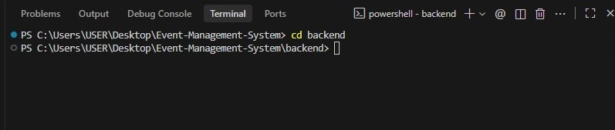
      - Activate the virtual environment
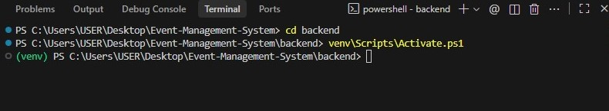
      - Install the requirements
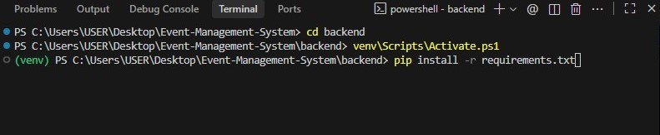

Running the Application
Backend

      - Start the Server: In the client directory on the client machine, launch the server development server using the command below:

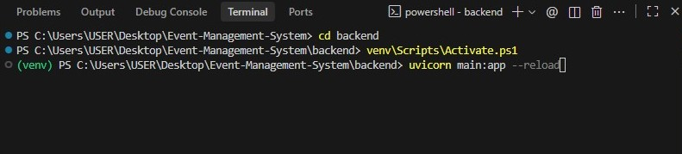
      - Access the Application: Open your web browser and navigate to the specified URL or IP address where the client is running, usually:
http://127.0.0.1:8000

Frontend

      - Start the app: In the project directory, launch the React Native development server using the command below:
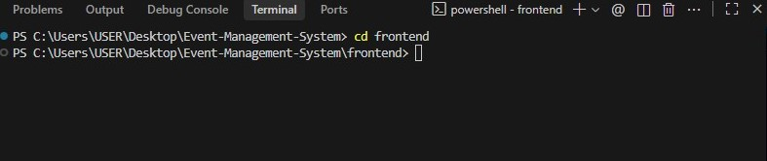
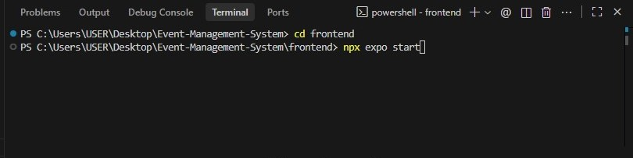

4.4 System Result Output
Based on the designed architecture, the mobile-based Event Management System is expected to deliver several key outputs upon implementation. The system will provide secure user registration and login features with real-time authentication and permission control. Users will access a dynamic interface to create, manage, and track events across various stages.
The system will also support real-time push notifications for event updates, reminders, and announcements, ensuring users remain informed and engaged. Task management outputs will enable organizers to assign, monitor, and update event activities efficiently.
Additionally, the application will generate activity logs and performance summaries for organizers, improving coordination and event evaluation. These outputs collectively ensure a responsive, user-friendly, and secure platform for effective event management on mobile devices.
4.5 Discussion
The development of the mobile-based Event Management System successfully achieved the objectives set out in this study. The system provides a secure platform for user registration and authentication, ensuring that only authorized users can access event features. It also allows users to create, manage, and track events effectively, improving organization and coordination.
The integration of task management enables users to monitor event stages and responsibilities, reducing confusion and improving productivity. Additionally, the inclusion of real-time push notifications keeps users updated on event changes, reminders, and announcements, promoting timely engagement and participation.
Testing and evaluation of the system confirmed that it performs efficiently on both Android and iOS devices, with a user-friendly interface that enhances accessibility for all types of users. Overall, the implementation demonstrates that a mobile-based solution can significantly improve the efficiency, communication, and management of events compared to traditional manual systems.

4.6 User Interface Design

This section shows screenshots of the key features of the system and descriptions of their functionalities.
Index Page: This is the first page the user interacts with the first time they search for the system in the mobile app.
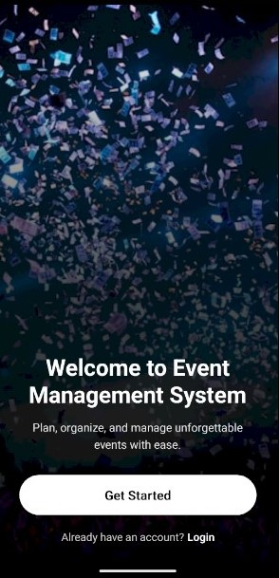
Figure 4.6.1: Index Page

Registration
New users need to register so as to access all the functionalities that the system provides to them.

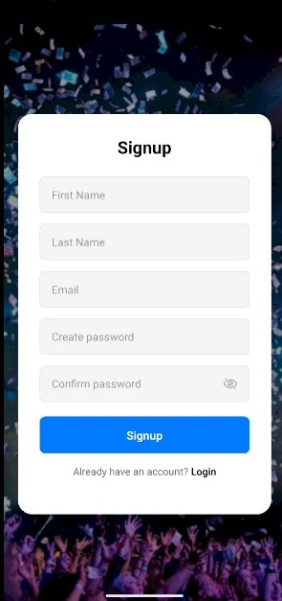

Figure 4.6.2: Registration Form

Login

Through this interface, an already registered user cans access the system.

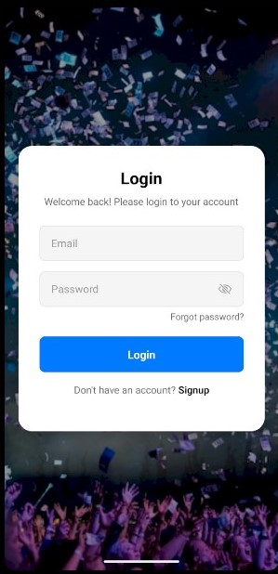
Figure 4.6.3: Login Form
Home
On this screen, users can create event, view upcoming events, featured activities, and important announcements.

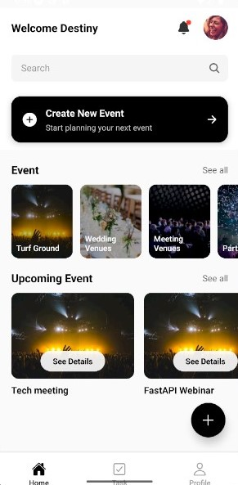

Figure 4.6.4: Home Page

Event
On this screen, users can explore and discover various events that match their interests.

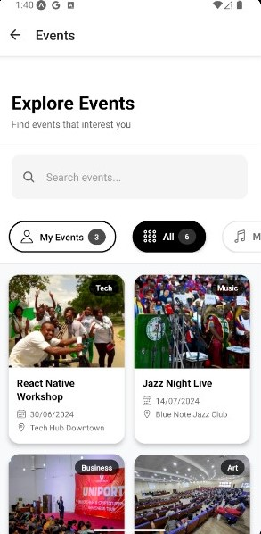

Figure 4.6.5: Event Menu

Event Details
On this screen, organizers can manage their event, edit or delete it, and handle related tasks.

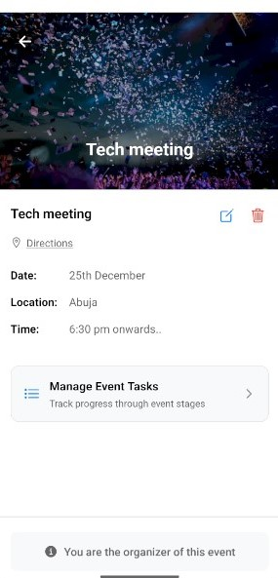

Figure 4.6.6: Event Details Page

Event Details
On this screen, attendees can view event information, schedule, location, and register for event.
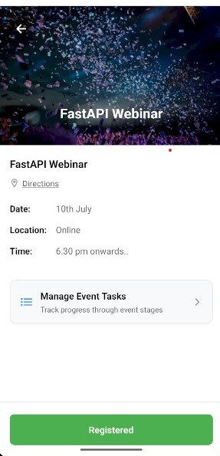

Figure 4.6.7: Event Details Page

Create Event
On this screen, users can create new event.

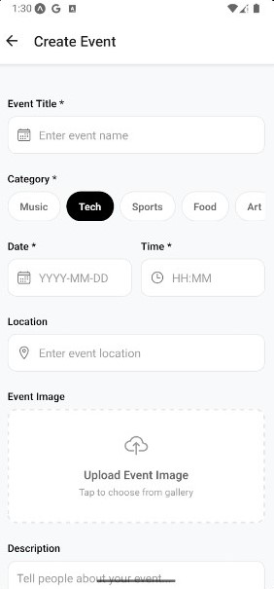

Figure 4.6.8: Create Event Form

Task Menu
On this screen, users can view available event task and event organizer can edit or delete event task.

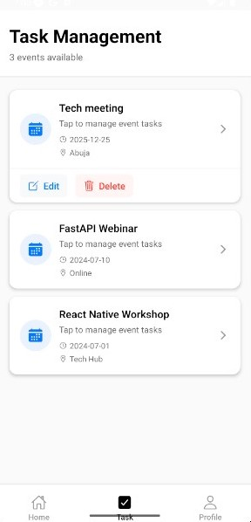

Figure 4.6.9: Task Menu
Task Management
On this screen, event organizer can view and manage tasks related to different stages of the event, such as planning, promotion, and execution.
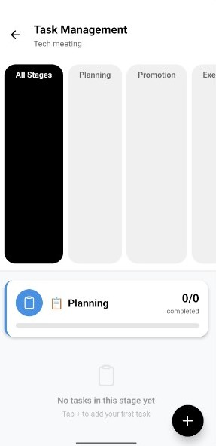

Figure 4.6.10: Task Management Page

Create Task
On this screen, event organiser can create event tasks.

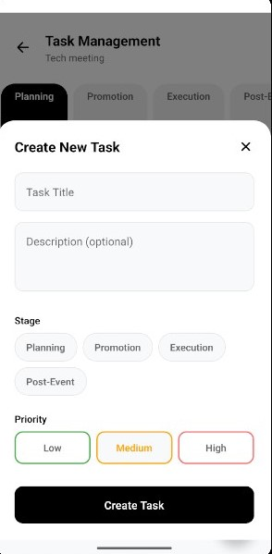

Figure 4.6.11: Create Task Form

Notifications
On this screen, users can view updates, alerts, and reminders related to their activities and events.
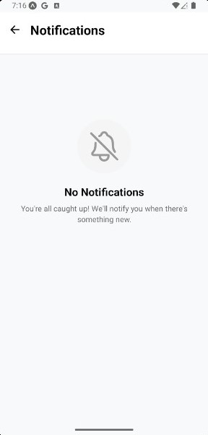

Figure 4.6.12: Notification Page

Profile Page
On the screen users to view their personal information and logout.

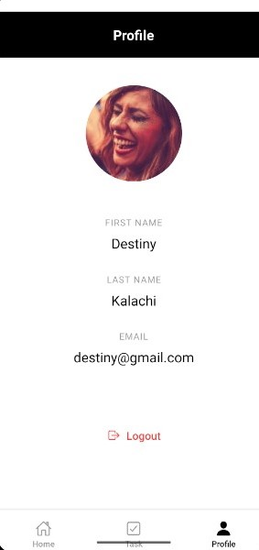

Figure 4.6.13: Profile Page

Admin Login page

On this screen, the administrator enters username and password to access the admin dashboard securely.

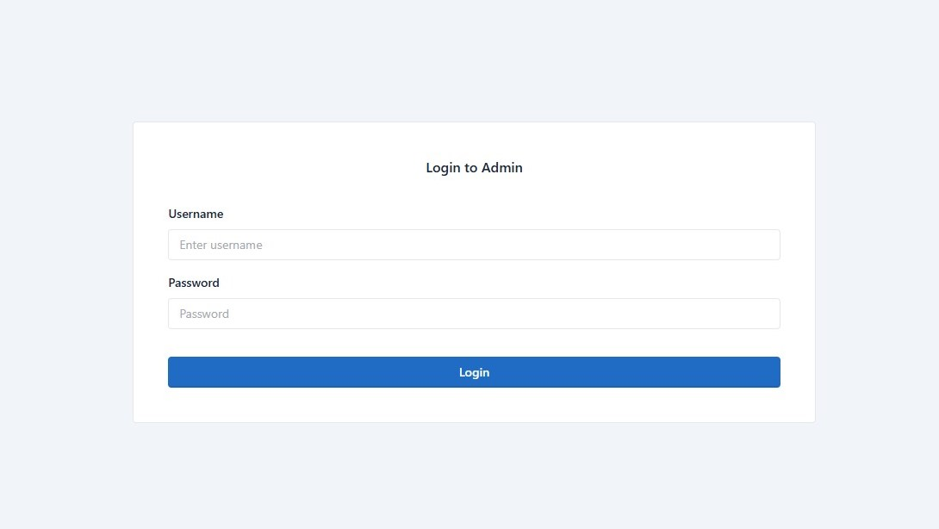
Figure 4.6.14: Admin Login Form

Admin Dashboard

On this screen, the administrator is offered the functionality to manage users and events.

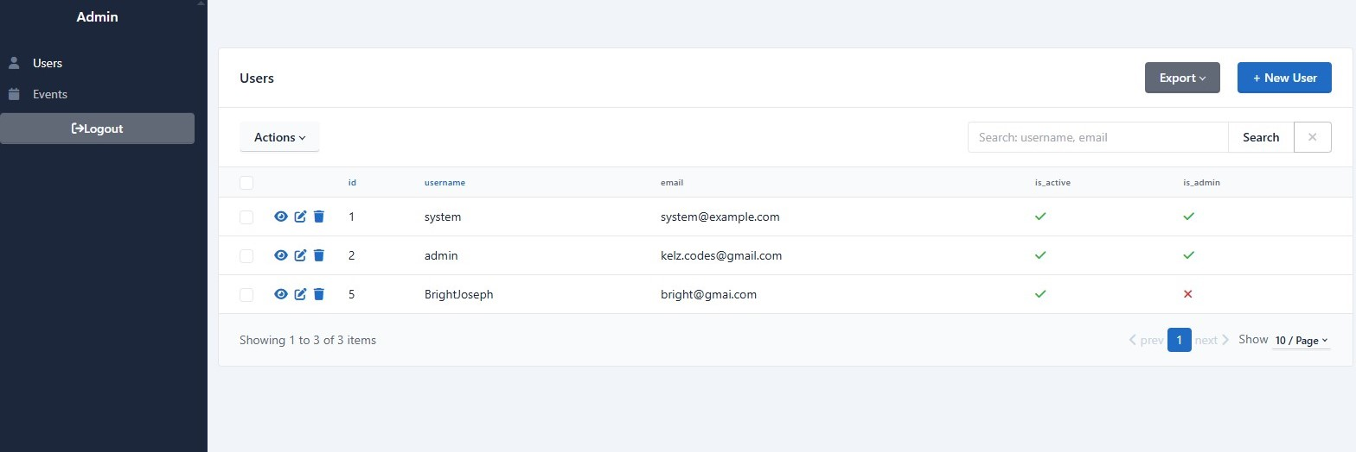
Figure 4.6.15: Admin Dashboard

  - System Testing
No matter how carefully a system is designed and implemented, errors can still occur. Therefore, testing was conducted to identify and correct issues in the mobile-based Event Management System. The main objective of the testing process was to detect any functional or performance errors during implementation. Identified errors were fixed through debugging to ensure the system operates smoothly and meets its intended objectives.

4.7.1 Unit Testing
Unit testing was carried out to verify that each individual component of the Event Management System works correctly. Each module such as user registration, login, event creation, and task management was tested separately to ensure it performs its intended function.
This testing helped identify minor errors early in development, which were corrected through debugging. By testing each unit independently, the overall reliability and performance of the system were improved before integration.
4.7.2 Integration Testing
Integration testing was performed to ensure that all modules of the Event ManagementSystem work together as expected. After individual units were tested, they were combined to check the interaction between components such as the frontend (React Native), backend (FastAPI), and database (PostgreSQL).

4.7.3 Compatibility Testing
Compatibility testing was carried out to ensure that the Event Management System works properly across different devices, operating systems, and environments. The application was tested on various Android and iOS versions to confirm that all features, such as user registration, event management, and notifications, function consistently.
4.7.4 Acceptance Testing
Acceptance testing was performed to ensure that the Event Management System meets all user requirements and functions as expected. Selected users tested the system’s main features, including registration, login, event creation, task management, and notifications.

